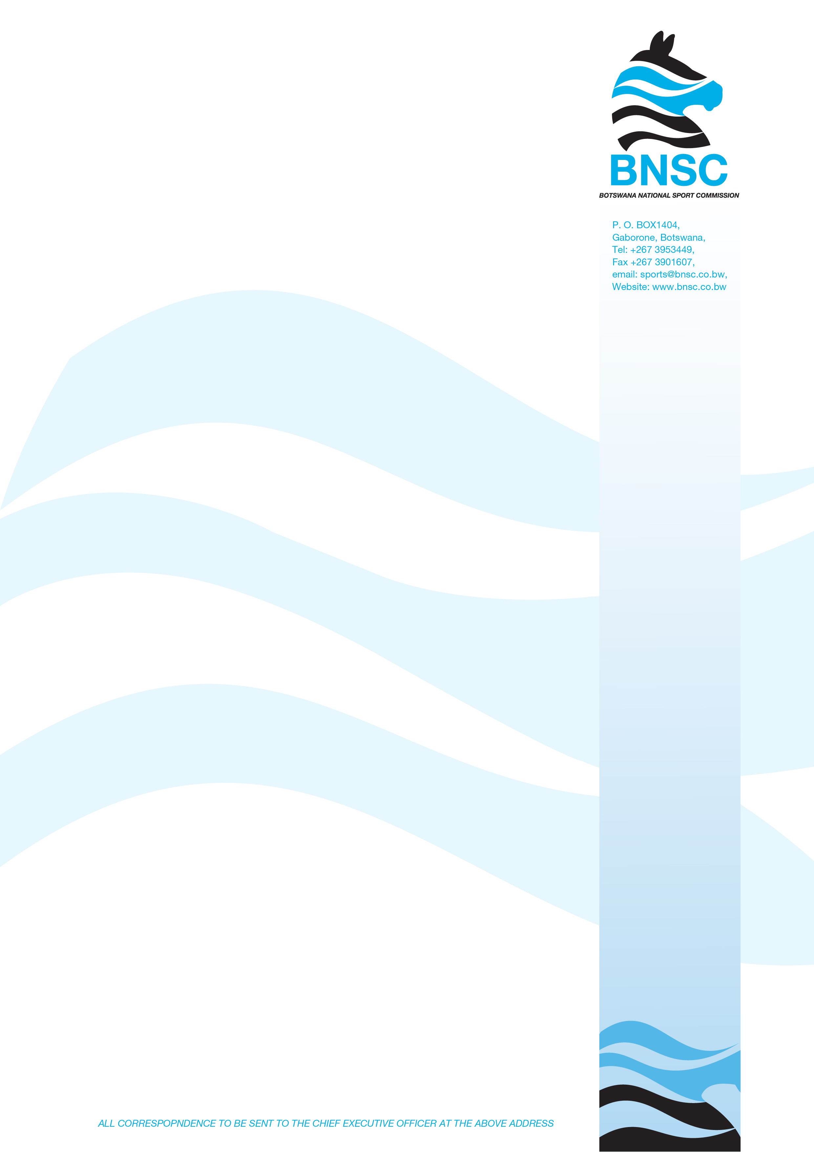

NOTICE OF CANCELLATION OF TENDERS

The Public is informed that the below referenced Tenders have been cancelled in terms of Public Procurement Regulation 2023 No. 66 (4c) which states that the tender cancellation is permitted where there is a significant change in scope of requirements of the tender. The scope & procurement need has significantly changed for both tenders.

Tender Reference Number | TENDER: BNSC/SDD/02/2026
Title of Procurement | PROVISION OF CONFERENCE,ACCOMMODATION AND RELATED SERVICES FOR THE 30TH TAFISA WORLD CONGRESS 2027
Method of Procurement | Open Domestic Bidding Method
Decision | To be re-tendered
Date of display | 7th April 2026
Date of removal | 16th April 2026

Tender Reference Number | TENDER: BNSC/CS/IT/08/2025
Title of Procurement | PROVISION OF SAGE ACCPAC MAINTENANCE & SUPPORT SERVICES FOR A PERIOD OF THREE (3) YEARS
Method of Procurement | Open Domestic Bidding Method
Decision | To be re-tendered
Date of display | 7th April 2026
Date of removal | 16th April 2026

Any inconveniences caused by such cancellation is highly regrettable.

